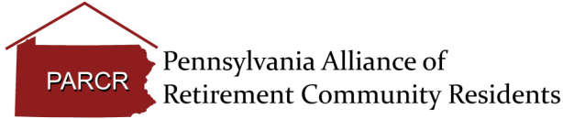

Gail Stelger, Legislative Chair
Email: legislative@parcr.org

State Senate Tidbit

According to LeadingAge PA, the Senate is set to return on August 30, 2023 to begin work to finalize the budget. The state Senate will begin finishing the final pieces of the 2023-2024 state budget. While the general appropriation bill was signed into law on Aug. 3, the PA General Assembly has yet to pass coinciding code bills that carry out the state spending plan. Following this step there should be more clarity around budget funding and efforts to mitigate nursing facility rate volatility. The House is not scheduled to return until Sept. 26. LeadingAge PA reported efforts continue to press for funding details through the ongoing advocacy conversations with the legislative and executive branches and will update its members once there is more information to share. In the meantime, please reach out to Legislative Affairs Director Austin Cawley if you have any questions.

